Experiment No.-5

1. Create a tuple and display its elements
t = (10, 20, 30, 40, 50)
print("Tuple elements are:")
for i in t:
print(i)
OUTPUT-
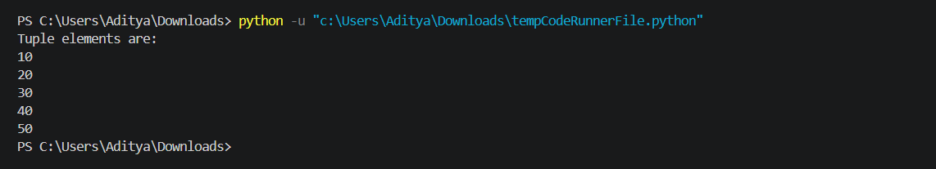

2. Find sum and average of tuple elements
t = (10, 20, 30, 40, 50)
total = sum(t)
avg = total / len(t)
print("Sum =", total)
print("Average =", avg)

OUTPUT-

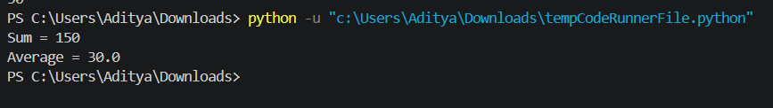

3. Find maximum and minimum in a tuple
t = (10, 20, 30, 40, 5)
print("Maximum =", max(t))
print("Minimum =", min(t))

OUTPUT-
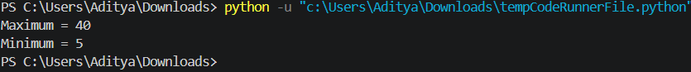

4. Demonstrate tuple packing and unpacking
# Packing
t = (1, 2, 3)
# Unpacking
a, b, c = t
print("Tuple:", t)
print("Unpacked values:")
print("a =", a)
print("b =", b)
print("c =", c)
OUTPUT-
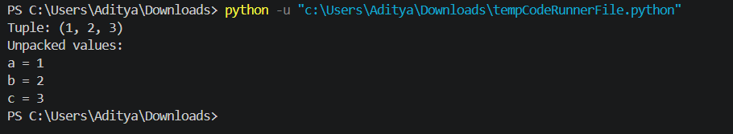

5. Convert tuple into list
t = (10, 20, 30)
l = list(t)
print("Tuple:", t)
print("List:", l)
OUTPUT-

6. Create and perform set operations
s = {1, 2, 3, 4}
# Adding element
s.add(5)
# Removing element
s.remove(2)
print("Updated set:", s)
OUTPUT-
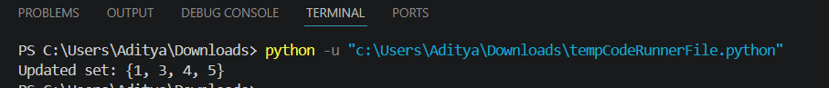

7. Find union, intersection and difference of sets
s1 = {1, 2, 3, 4}
s2 = {3, 4, 5, 6}
print("Union:", s1.union(s2))
print("Intersection:", s1.intersection(s2))
print("Difference (s1 - s2):", s1.difference(s2))
OUTPUT-
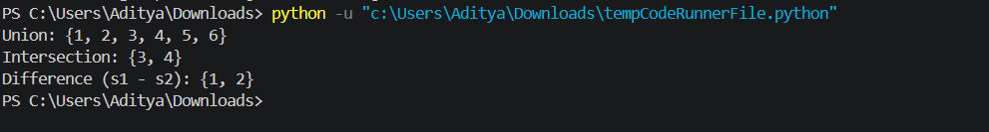

8. Remove duplicate elements using set
l = [1, 2, 2, 3, 4, 4, 5]
unique = list(set(l))
print("Original list:", l)
print("After removing duplicates:", unique)
OUTPUT-
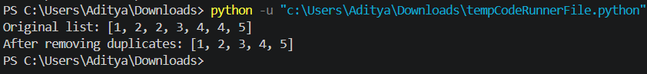

9. Check membership of an element in tuple
t = (10, 20, 30, 40)
x = 20
if x in t:
print(x, "is present in tuple")
else:
print(x, "is not present in tuple")
OUTPUT-
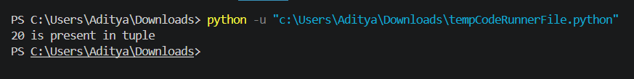

10. Count occurrences of an element in tuple
t = (10, 20, 30, 20, 40, 20)
x = 20
count = t.count(x)
print("Element", x, "occurs", count, "times")
OUTPUT-

